Time Travel Summer Adventure
American History

San Tan Charter School will be offering a summer program filled with exciting activities that take your students back in time. Our focus will be on American History. Our summer school program will offer students the opportunity to experience various cultures through video, dance, art, storytelling, food, sports, foreign language, math, science, history and other hands on activities. Each week we will take a time-machine back to a different era:

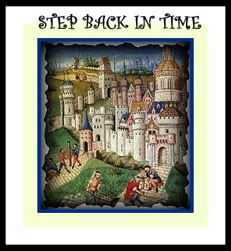

Weeks 1-2 (June 5th -16th): Spanish Conquistadors
Weeks 3-4 (June 19th – June 30th): Native American History
CLOSED Monday & Tuesday, July 3rd - 4th
Weeks 5-6 (July 5th – 14th): Pilgrims & Early Settlers
Weeks 7-8 (July 17th – 28th): American Revolution
As part of our explorations we will also learn to speak and write a few basic words and phrases in Gaelic, French, Spanish, and Old English.
Students are free to sign-up for all or part of the program and are expected to bring their own lunch and snacks each day.

Tentative Daily Schedule
8:20 – 8:50: Morning Recess
8:50 – 9:20: Music & Games
9:20 – 10:20: Art Time
10:20 – 10:50: Snack & Recess
10:50 – 11:00: Foreign Language
11:00 – 11:20: Play Math
11:20 – 11:50: Story Time
11:50 – 12:20: Lunch Recess
12:20 – 12:40: Lunch
12:40 – 1:10: Reading Time
1:10 – 1:40: Special Activities (Math Madness Mondays, Water Wednesdays, Cooks in the Kitchen Thursdays, Science Fridays),
1:40 – 2:10: Math Games
2:10 – 2: 40: History Time (Explore American History through Art, Videos, & Stories)
2:40 – 3:30: Clean up and indoor game time

