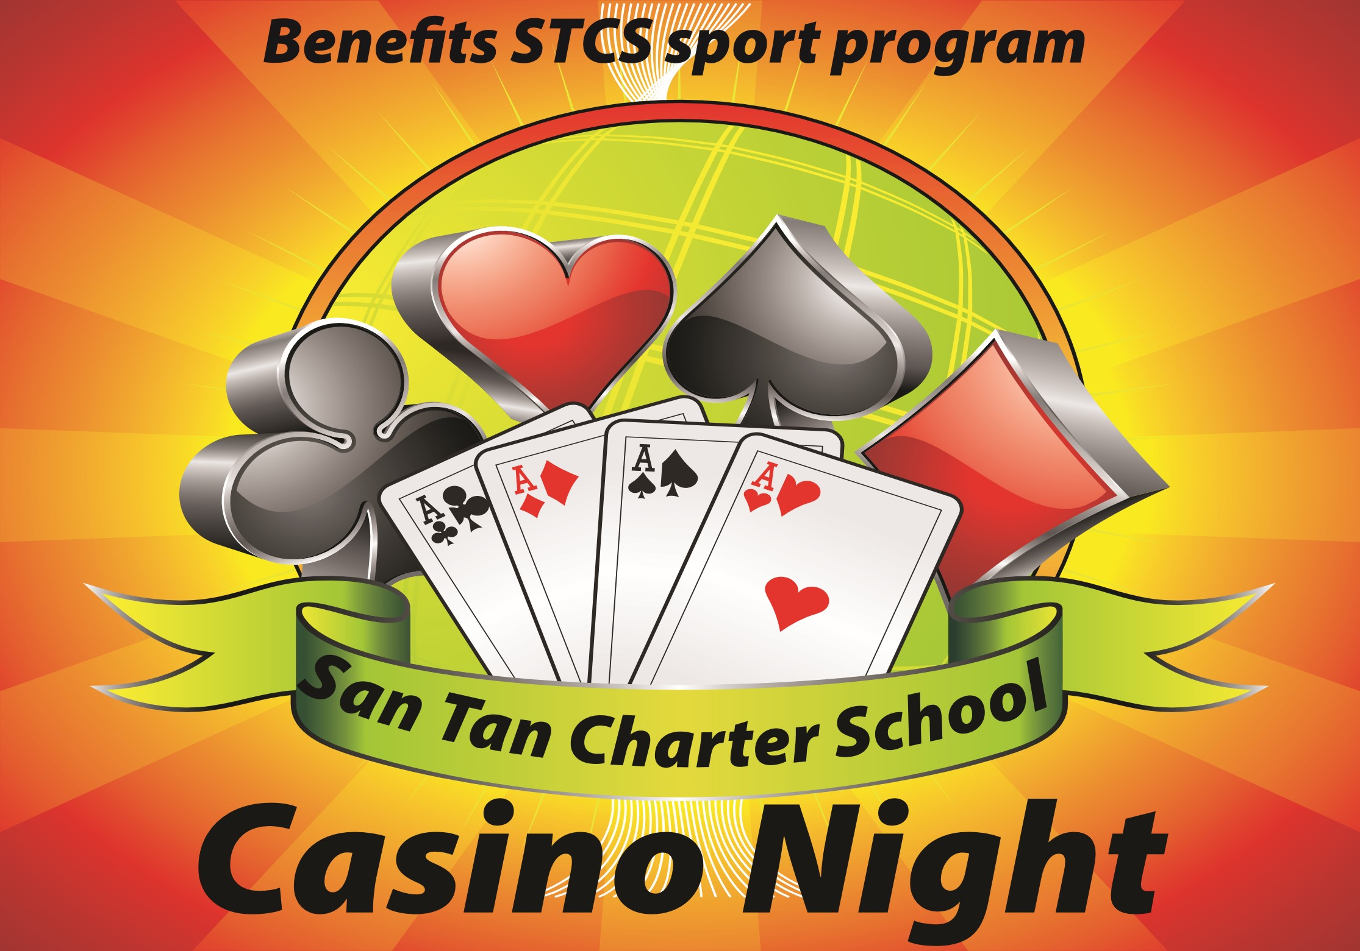

**Saturday, November 19th**

**7-10pm, STCS Gym**

Texas Hold'em $40

(includes 1 drink ticket, $100 fun money)

Casino Night $25

(includes 1 drink ticket, $50 fun money)

Texas Hold'em & Casino Night Combo $60

(includes 2 drink tickets, $ 200 fun money)

SIGN UP AND RETURN TO OFFICE, OR SIGN UP ONLINE! [**http://tinyurl.com/jfxddyu**](http://tinyurl.com/jfxddyu)

Family Name:____________________________ Contact Info:____________________

#Texas Hold’em:________ #Casino Night:__________ # Combo:_________

TOTAL AMOUNT: ____________________ Paid: ___________ Initials:_______

Cash:______ Check:______ CC: _______